Penrose Tiles for Class Use.
Both are used under a Creative Commons license. To be a legal tiling, the appropriate colors have to line up.

Kites and Darts

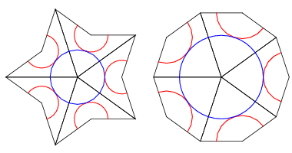

Rhombus
